Jackalope Wine Cellars
2016 Silvershot Vineyards Pinot Noir

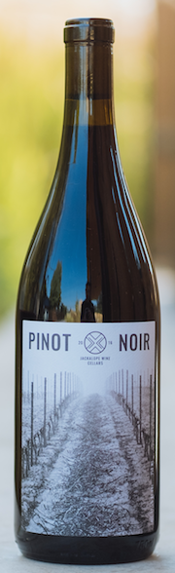

Vineyard: Silvershot
AVA: Eola-Amity
Notes: Dry-farmed; Own-rooted. 250-450 feet in elevation; Chehulpum soil; planted 1999.
Harvest Date: 9/5 and 9/17/16
Clones: 114, 115,
Whole Cluster: 10%
Spontaneous fermentation
Aging: 11 months in neutral French Oak
Alcohol: 13.5%
Cases Produced: 100
Release date: February, 2018.

The wine was spontaneously fermented in 1.5 ton open topped bins, getting punchdowns once per day. The wine was aged for 11 months in used French oak barrels and was hand-bottled unflitered and unfined.

