Jackalope Wine Cellars
2017 Voyager Viognier

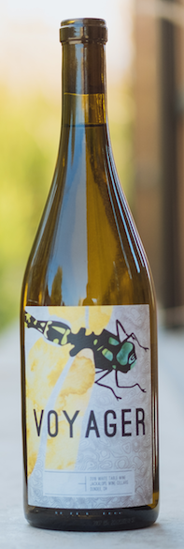
Vineyard:
50% Lange of Underwood (WA)
50% Sera Vineyard (OR)
AVA: Columbia Valley (WA), Rogue Valley (OR)
Spontaneous fermentation
Aging: WA fruit was fermented and aged in stainless steel. The OR fruit was fermented and aged in neutral French oak.
Alcohol: 12.4%
Cases Produced: 100

The Rogue Valley vineyard fruit brings tropical, riper notes to the wine. This is balanced with the Columbia Valley fruit that brings citrus and high levels of acid. The finished wine is bright and lively; citrus and melon and maybe a little mango wrapped up with spring flowers.

