Jackalope Wine Cellars
2018 Merlot

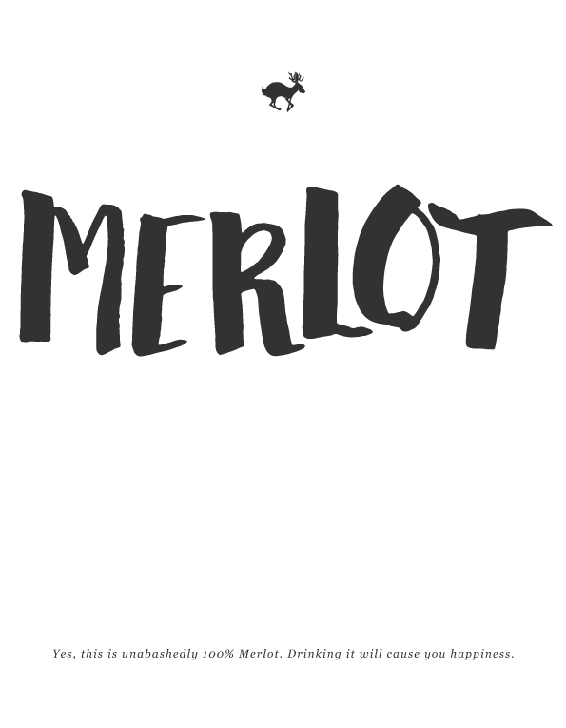
Vineyard:
Layne Vineyard (Applegate Valley, OR). Planted in 1977. Dry-farmed and organic.
Notes:
Harvested 10/5/2018.
Winemaking:
Spontaneous fermentation
30% whole cluster
Aging: 11 months in neutral French Oak
Alcohol: 14.5%
Cases Produced: 160

All the fruit was spontaneously fermented in 1.5 ton open topped bins, getting punchdowns twice per day. The wine was aged for 11 months in used French oak barrels and was hand-bottled unflitered and unfined.

This is my second vintage of Merlot. I’m in love with the grape, and this vineyard. Sure it is a little fruity, but that’s mixed in with nice earthy-ness, a sprinkling of pencil shavings, an all-around fun wine. Take that, Sideways, Merlot is back!

