Jackalope Wine Cellars
2018 Red Blend

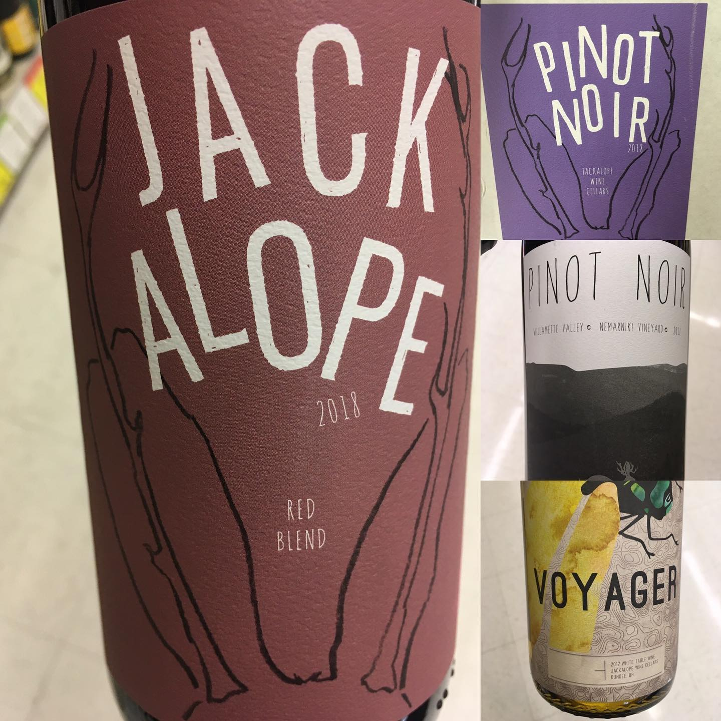
Vineyards:
Weets Family Vineyard and Seven Mile Vineyard (Columbia Valley, WA), Eevee’s Vineyard (Applegate Valley, OR)
Notes:
75% Cabernet Franc, 12.5% Cabernet Sauvignon, 12/5% Merlot.
Winemaking:
Spontaneous fermentation
Aging: 11 months in neutral French Oak
Alcohol: 14%
Cases Produced:245

All the fruit was spontaneously fermented in 1.5 ton open topped bins, getting punchdowns once per day. The wine was aged for 11 months in used French oak barrels and was hand-bottled unflitered and unfined.

I used fruit from both Oregon and Washington, with the goal being a blend reflecting the Pacific Northwest. Each vineyard was fermented separately. In the summer of 2018 the team tasted through all barrels to come up with this blend. Once barrels were selected, they were blended and put back in barrel for another month until bottling.

