Jackalope Wine Cellars
2018 Willamette Valley Pinot Noir

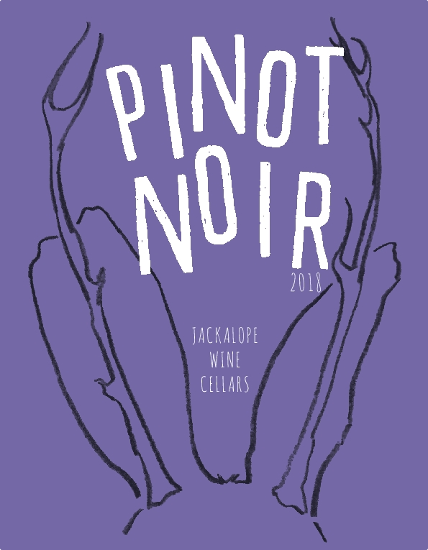
Vineyards: Silvershot Vineyards (Eola-Amity AVA) and Nemarniki Vineyard (Chehalem Mountain AVA)
Notes:
Silvershot is a dry-farmed and own-rooted. 250-450 feet in elevation; Chehulpum soil; planted 1999. Organic adjacent farming.
Nemarniki Vineyard planted mid-2000s. 650-800 fet in elevation. Laurelwood soil with a base of volcanic soil.
Winemaking:
Spontaneous fermentation
Aging: 11 months in neutral French Oak
Alcohol: 14%
Cases Produced:245

The wine was spontaneously fermented in 1.5 ton open topped bins, getting punchdowns once per day. The wine was aged for 11 months in used French oak barrels and was hand-bottled unflitered and unfined.

My goal with this wine was a blend showing a winder picture of the Willamette Valley than you would get in a single vineyard wine. I wanted to bring the earth-y red fruit of Silvershot, and pair it with the darker fruited and more floral Nemarniki.

